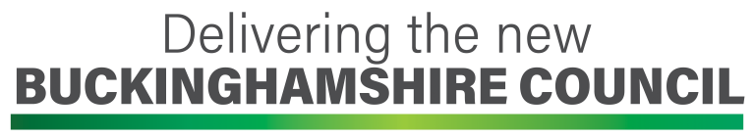
Information for heads to deliver to staff in January
The following was put together to help you update your colleagues about the latest development – further updates will follow.

You will probably already have heard that the government has decided that from 1 April 2020 there will be one new council for Bucks called Buckinghamshire Council. It will replace Buckinghamshire County Council and all of the district councils and provide all the services of the current councils. Employees of the current councils will automatically transfer across to the new council from that date.

This has an effect on all staff who work for schools where Buckinghamshire County Council is currently the legal employer. So this applies to BCC-controlled schools (including special schools and Pupil Referral Units) and Voluntary Controlled schools. Buckinghamshire Council will become the new employer when it comes into being on 1 April.

It does not apply to Academies, Foundation or Voluntary-Aided schools.

All of your employment rights will be protected in the move to the new council, because this is covered by specific legislation known as the TUPE regulations. TUPE stands for Transfer of Undertakings and Protection of Employment Regulations.

As the current employer, Buckinghamshire County Council has now started to formally consult with all the recognised trades unions about the transfer. This formal consultation period will continue until 17 January.

In the meantime we have information that they have provided to us so we can keep you up to date with what is happening. This includes:

- A consultation document
- An information pack about what schools need to know
- Frequently asked questions and answers (these will be updated on a regular basis as new questions arise)

These documents are available electronically; details of how to access them can be found on the staff noticeboard.

You can find out more about the new council on the website www.shadow.buckinghamshire.gov.uk

There is also a lot of helpful guidance and information on a shared online space set up for all staff employed by the current councils, which schools staff can access by:

- going to internal.buckinghamshire.gov.uk
- username Staff
- password 1stApril2020!

We want you to feel able to ask any questions that you might have about this change and I would encourage you to do so.

There is one administrative change that will take place on the 1 April that you need to be aware of. This is that all staff who are eligible to be in the Local Government Pension Scheme or the Teachers’ Pension Scheme will be automatically enrolled in the scheme at the point when you transfer to become an employee of the new Buckinghamshire Council. There will be no change in pension provisions for employees. All this means is that if you are currently in the scheme there is no change for you, however if you have previously chosen to opt out of one of these pension schemes, you will be automatically placed into their relevant scheme as you transfer to the new employer. More information will be provided after the transfer about this, including how you can opt out if this is what you wish to continue to do.

However, I just want to reassure you that aside from this, the upcoming change of your employer from Buckinghamshire County Council to Buckinghamshire Council will not otherwise impact you, your job or the teaching and learning for the children in your care.

We will keep you informed about the transfer as things develop.

Dec 2019

