Buckinghamshire SchoolsWeb - how to register a school closure.

1 Log into SchoolsWeb, using your Senior Management account
It is important to make sure that anyone who may be required to set a closure or update has the login details at home in case they need to self-isolate

2 Click Emergencies at the top of any page
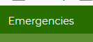

3 Click the Register closure button
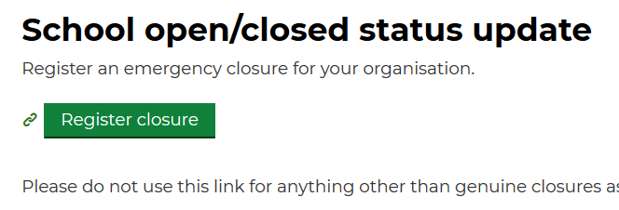

4 Fill in and submit the closures form.

Please note
- The Start date defaults to the current day. In the event of a partial or full closure due to COVID-19, this will need to be adjusted if planning for a future day.
- The Back to normal operation date defaults to the following day. This means that your school will return to showing an ‘Open as normal’ status the next day. Consider carefully how long your closure will be in the first instance – this can be revised if the situation develops.
- Please consider whether the school needs to close fully or partially and if there are any ancillary services that can be provided to pupils (particularly those who are vulnerable). Make this clear in the notes and also be aware that these will be publically visible.
- Please enter your name and position in the school. If you are not authorised to close a school yourself, please use the ‘consulted with’ box to say who authorised the closure.

