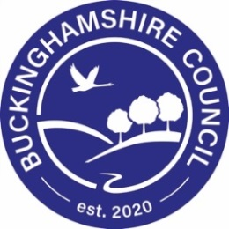
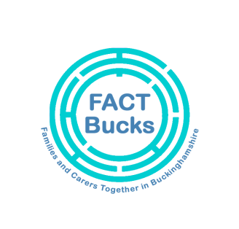
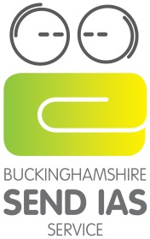

Annual Reviews during the COVID-19 Pandemic
Buckinghamshire Guidelines

Introduction
During the COVID-19 pandemic, the guidance from UK government regarding school closures and social distancing means that the annual review process will not be able to be conducted in the same way. No notice has been issued by the government to disapply the duty to conduct annual reviews and so these must continue to take place. However, the government has legislated to provide extra flexibility over the timing of these reviews. Where it is impractical to complete an annual review of an EHC Plan within the prescribed timescales for a reason relating to the incidence or transmission of coronavirus (COVID-19), then it must be completed as soon as is reasonably practical. There is no change to the statutory deadlines for phase transfer reviews.

The main principle underpinning all of the annual reviews is to ensure that the child or young person is at the centre of the process and can engage with the process in a meaningful way. Creative methods will need to be undertaken to ensure that as far as possible annual reviews continue to take place in a timely way and that the most accurate, reliable and comprehensive information is gathered and collated, given the constraints in place. Routine delay of annual reviews is not lawful.

Annual review meetings
We recommend that, where possible, virtual platforms are used to hold annual review meetings. We recognise this is an extremely difficult time for all, and that holding such meetings maybe unusual, but we want to enable the opportunity.
EHC Coordinators have taken on new caseloads from the 6th April, and have made contact with SEN leads for schools that are now on their new caseloads. Should you have any specific questions around how annual reviews could work, please do liaise with them. We are regularly maintaining our online information via schoolsweb, schools bulletin and the Local Offer so do continue to check those.
We will be available to support with the arranging of virtual meetings where it is requested by families or settings, so do request this if needed. We wish to assure you that all iSEND staff members maintain full access to emails and electronic files during this time and will be happy to answer any queries that you may have.
In some cases, it will be more difficult than usual to gather all of the information required for the annual review. The annual review Headteacher’s or Principal’s report should clearly indicate which information is missing, the reason why it is missing and how and when it will be obtained.
We request that following the Annual Review meeting, settings send any paperwork to their area via email or anycomms, not via post please, using the following address or directly to your EHC Coordinator:--
- SEN Aylesbury Hub: senaylesbury@buckinghamshire.gov.uk
- SEN Wycombe Hub: senwycombe@buckinghamshire.gov.uk
- SEN Chiltern South Bucks Hub: sencsb@buckinghamshire.gov.uk
Local Authority decision – following Annual Review
While staff remain healthy and able to work, we are committed to continuing to process Annual Reviews in a timely manner. Where this is not possible because of a reason related to COVID 19, this will be done as soon as is reasonably practical. The following are the potential outcomes, following Local Authority consideration of annual review paperwork:
- Continue to maintain the EHC plan in its current form
- Agree to amend the EHC plan
- Cease to maintain the EHC plan
Local Authority - Issuing Letters / Proposed Amended Plans
EHC Coordinators will draft and issue any Proposed Amended Plans / intentions to cease to maintain the EHC Plan. Educational institutions will be consulted with through agreed points of contact and given calendar 15 days to respond. It is important to note that this timescale remains unchanged in the current situation, and that settings are expected to provide a response to the consultation within 15 days, based on their consideration of the paperwork provided.
We are aware that communication within educational establishments may be challenging at this time, and are looking at ways to improve communication including a specific list of consultations to be sent to special schools and discussed in weekly meetings with your designated EHCCo. Every effort will be made to ensure that full and clear information is given to settings and understood by the correct point of contact. Should a weekly meeting not be possible, EHCCos will ensure Proposed Amended Plans are sent to the agreed contact for each setting and parents / young people electronically. Parents / young people will then have 15 days to respond if further amendments are required. We recognise, however, that absence because of illness, self-isolation etc may affect the speed with which a family or setting can reply. In such circumstances, families and settings will need to communicate with their EHCCo about a possible delay in responding.
Once agreed, a Final Amended EHC Plan can be issued. If no amendments are required to the EHC Plan, a letter will be issued electronically to say that the plan will remainin its current format. Visit the Government website for the latest guidance in relation to amendments to the SEN legislation.
Bucks SENDIAS Service is available for free, impartial, confidential information, advice and support on all matters relating to SEND for children and young people with SEND and their parents/carers. Please email sendias@buckscc.gov.uk or call 01296 383754

