Buckinghamshire Council
Microsoft Teams Instructions
Teams can be accessed from the web browser, a desktop application, or a mobile app.
1 Go to https://teams.microsoft.com. You will see a sign in page with the option to create an account or the sign in options:

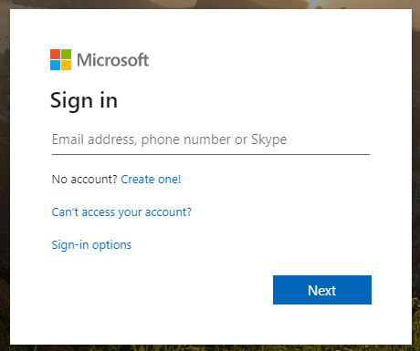

2 Enter your email address and you will be prompted to create an account.

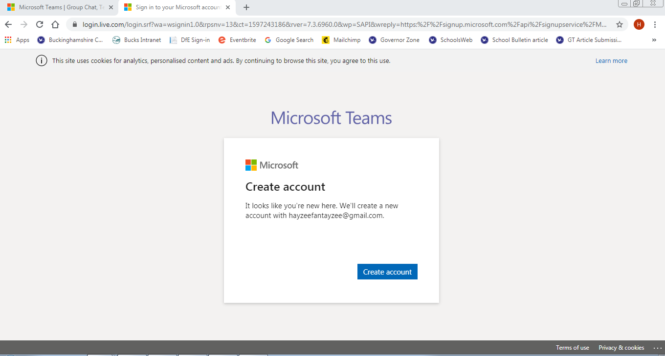

3 You will be required to verify your account with a code sent to your email address, so ensure you are able to do this in time.

4 Dismiss any pop-ups and click the Teams button on the toolbar on the left-hand side:

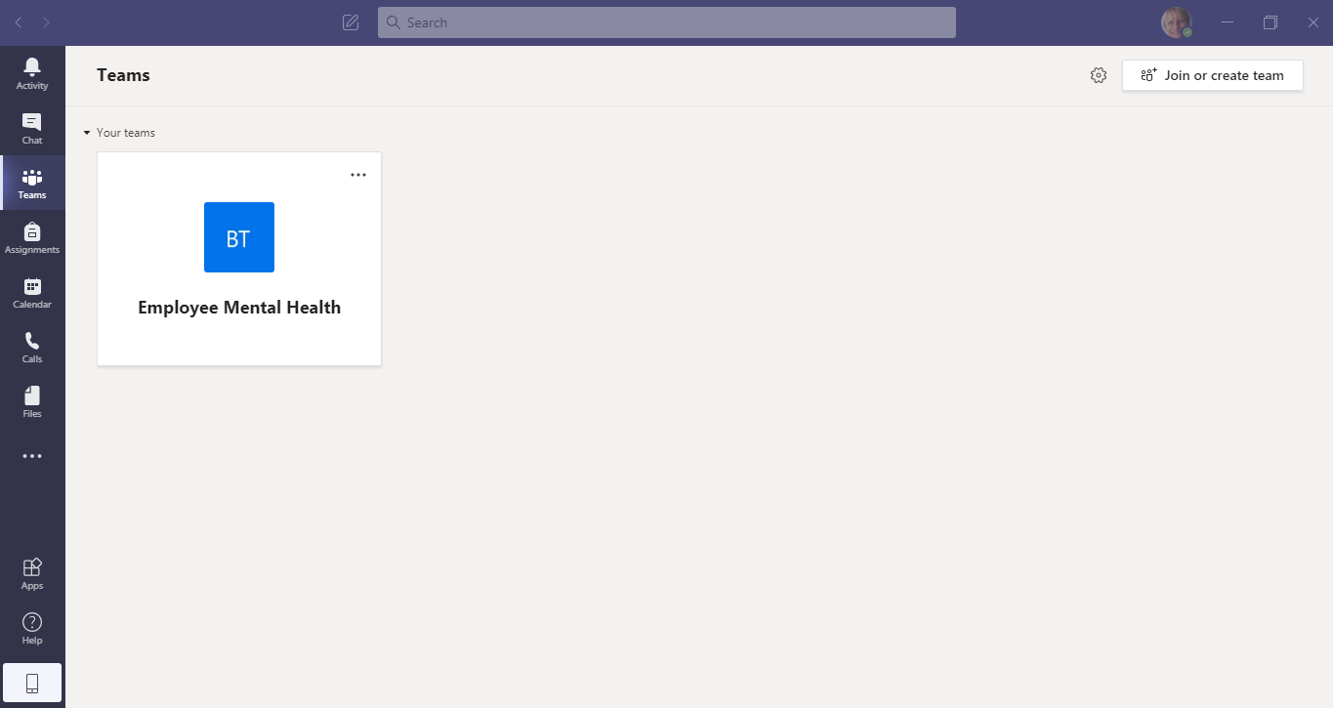

5 In the top right hand corner there is a box, click on this and enter the Teams meeting code you have been sent in the joining instructions, for this specific meeting.

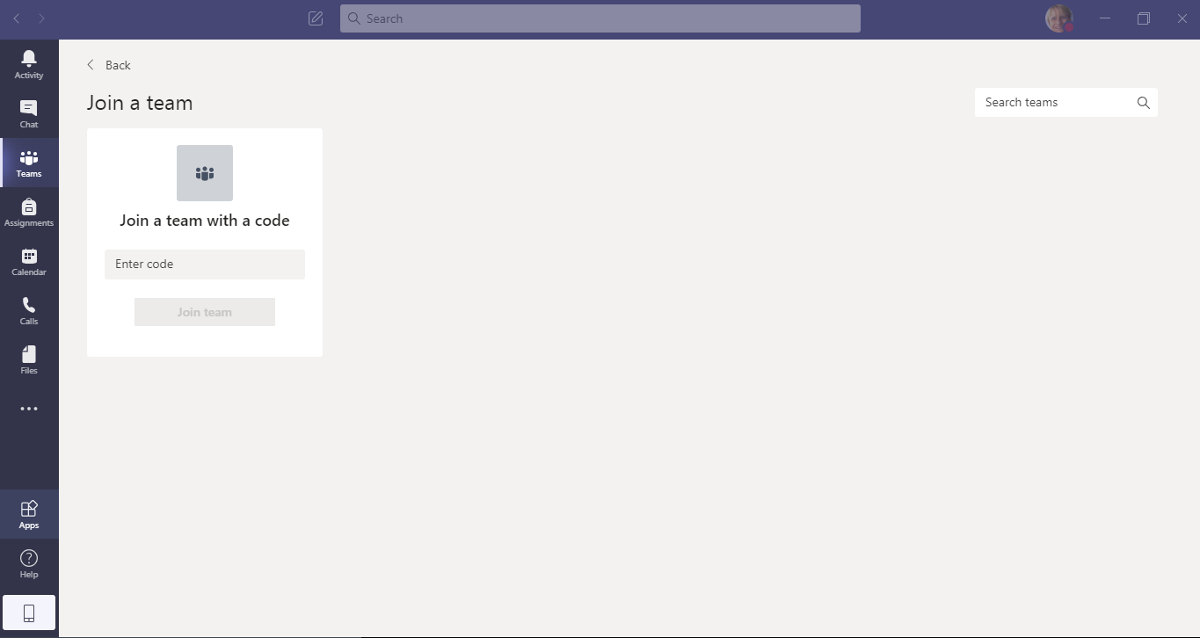

6 Make sure you disable video and audio on the joining screen before clicking “Join now”.

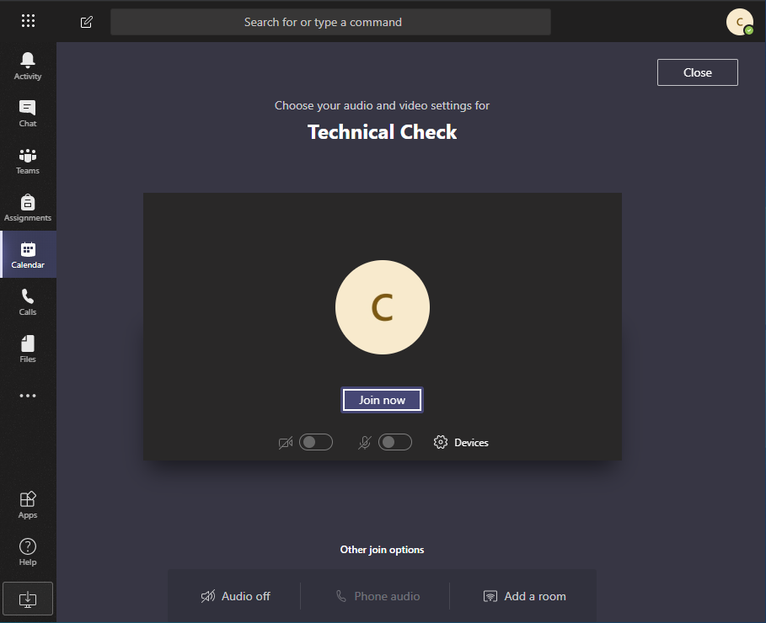

7 If you wish to submit a question click the ‘Chat’ icon on the black bar and a message bar will pop up on the right hand side where you can enter your question.
8 If you wish to ask a question click the ‘Hand’ icon on the black bar and you will be flagged up to the presenter. The presenter will ask you to speak, just remember to turn on your microphone.
9 At the end of the meeting, click the red phone button to hang-up.

