Troubleshooting for Courses on emails, Eventbrite and Teams

Where are courses for schools advertised? | - Courses for schools are posted in the School Bulletin. You will require a login to access this, ask your school office or Headteacher.  - Governor courses are posted in Governor Times. Ensure you select ‘All Dates’ in the drop-down box to see the latest information.  - The BASG website often posts details of courses available http://www.bucksgovernors.org/  - School Governance or School Improvement will also email information to Heads, Chairs and Clerks. Keep your contact details up-to-date and advise of any changes to sis@buckinghamshire.gov.uk or schoolgovernance@buckinghamshire.gov.uk
The link in the promotional email doesn’t work | - Hover your mouse pointer over the highlighted/underlined text and a box should appear advising you to ‘click’ or ‘ctrl+click’ to follow link.  - You may need to right-click the link and select ‘Open Hyperlink’.  - You can also copy the link and paste in your search engine.
I don’t see highlighted text | Your email must be set to HTML in order to see links.  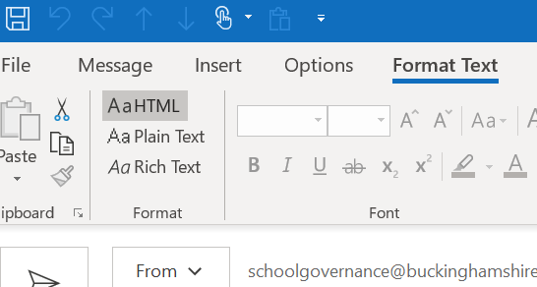
How do I register on Eventbrite? | Follow the links provided and enter your details. Make sure your email address is correct and it is one you regularly use as this will be used for contact regarding updates, changes, links and presentations.
I didn’t receive the Eventbrite confirmation | - When you register on Eventbrite you will be sent a confirmation automatically. If not check spam/trash or junk.  - Or you may have entered your email address incorrectly.  - Have you checked the right email account? Some people use more than one.
I didn’t receive an email with the link | - SIS or School Governance will send out one or 2 emails which contain the Teams link, 2 – 5 days before the event. If you do not receive this email check your spam/trash or junk.  - If nothing has been received contact sis@buckinghamshire.gov.uk or schoolgovernance@buckinghamshire.gov.uk  - Have you checked the right email account? Some people use more than one.
I am not familiar with Teams | - You do not need an MS account, you can log in as a guest. If you have Gmail you will already have an account.  - It is advisable to check your access 20-30 minutes prior to the meeting.
The link for the meeting isn’t working | - Are you using the correct link for Teams? It usually says Join Microsoft Teams Meeting followed by a phone number and a Conference ID: 458 462 694#  - Please note that courses cannot be accessed via Eventbrite.  - Have you got the correct link for the date and time? Some courses are repeated, so please check the date.
Eventbrite says the course is full or sales have ended | Contact sis@buckinghamshire.gov.uk or schoolgovernance@buckinghamshire.gov.uk as we can add you in most circumstances.
Eventbrite is blocked by my ISP | Contact schoolgovernance@buckinghamshire.gov.uk to book your place
I have logged into the meeting but have no chat bar/sound/picture | There may be a connection problem, try leaving the meeting and then log in again as this may fix the problem.
I am in the meeting and the presentation is not moving along | There may be an issue with wifi speed or a connection problem. Try leaving the meeting and then log in again as this may fix the problem.

