Liaison Group Anti Bullying Champion Network

An Introduction to the Project
We are excited to announce that we have been invited to select 18 schools in Buckinghamshire to participate in a national training programme, Equally Safe. The aim of the program is to create support networks who are embedding best practice approaches to creating equal and inclusive schools and, tackling identity-based bullying and who will continue building and sharing this practice after the intervention has ended.

Criteria for Participation
We welcome applications from a wide range of schools who meet the below criteria
    - Not be graded inadequate,
    - Have a stable Senior Leadership Team,
    - Are working to develop an Anti-Bullying strategy or have identified need to prioritise this work through their development plans.
    - Have recent positive feedback from Ofsted re: Behaviour and Attitudes and Personal Development

Each school will select two members of staff to lead on this work and will be allocated a lead representative from the organisation EqualiTeach, who will work extensively with them to deliver a bespoke package of support. Chosen Leads should aim to attend 67% of the events shown in the schedule.

Please submit your interest to your liaison group by Monday 4th October 2021

Liaison Group Nominations
As a liaison group, please can you consider and nominate 2 schools – one first choice and one reserve school – to become your Liaison Group Anti Bullying Champion School who will benefit from:

- An initial training event for school leads
- Resources and guidance to undertake a baseline assessment of their equalities and anti-bullying work
- Consultancy to support schools to update and strengthen policies
- Eight two-hour online twilight training events for school leads
- Whole-day events and follow up support for pupils to equip them to be Agents for Change Ambassadors
- In-house twilight training for all school staff
- Action planning meetings with staff leads to support them to implement initiatives and create positive change in school
- Assistance in communicating the work to parents/carers
- The creation of a network of peer support with other schools

Please can the liaison group select a school to respond, and email the name of your first choice school and reserve school to sis@buckinghamshire.gov.uk with the title ‘ANTI-BULLYING CHAMPION NETWORK’ by October 4th Once nominations have been submitted we will send confirmation along with the partnership agreement form.

We look forward to receiving your nominations.

Kind Regards

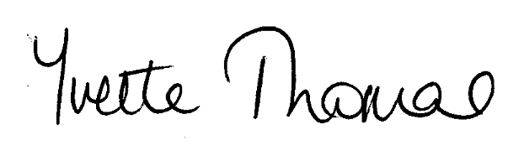

Yvette Thomas
Equality and School Improvement Manager

