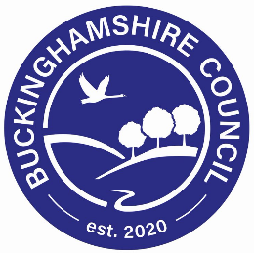

NHS Buckinghamshire Clinical Commissioning Group

Study Centre

New County Offices

Walton Street

Aylesbury

Bucks

HP20 1UA

Tel: 01296 585900

Email: [bucksccgs@nhs.net](mailto:bucksccgs@nhs.net)

1st September 2021

Dear Head Teacher,

**Covid Vaccinations for children/young people aged 12 -15**

As you may be aware, NHS England and the Joint Committee on Immunisations and Vaccinations (JCVI) are currently reviewing evidence on whether to recommend that all children aged 12 -15 years should be offered an initial dose of Pfizer-BNT162b2 Covid-19 vaccine. As such, NHS England and NHS Improvement have requested that we begin making plans to offer this element of the Covid-19 vaccination programme, if approved, over a 6-week period commencing 13th September 2021.

It has been agreed locally by NHS Buckinghamshire Clinical Commissioning Group, Buckinghamshire Council and Buckinghamshire Healthcare NHS Trust to deliver this through the School-Aged Immunisation Team (SAI) for the following reasons:

* Uptake for childhood vaccinations is traditionally higher when undertaken in schools
* The offer will be available to *all* children aged 12-15 in a very local environment, thereby promoting health equality for all.
* It causes less disruption for parents who would otherwise need to transport their child to a vaccination centre and possibly take time out of work.
* It is less distressing to a child/young person as they will be in a familiar environment.
* It minimises disruption to the school, as children will not need to be taken off-site during school time for their immunisation.
* The school-aged immunisation service is well-established and experienced in supporting and immunising this group of children, as they already successfully deliver all other immunisations for this age group.
* Where possible and practical we will work to provide the Covid vaccination and other vaccines (Flu/HPV) together – all delivered in the school. The school-aged immunisations service will ensure the timetables work around this in order to minimise disruption to schools.

The Mass Vaccination Service, operating from Stoke Mandeville Stadium and other venues in Buckinghamshire, will support the School Vaccination Team and will also offer a ‘catch up’ service for any child who may be absent/unwell on the day and for those undertaking home education etc. This service has already safely administered over 100,000 Covid 19 vaccinations to date.

A member of the School-Aged Immunisation Team (SAI) vaccination team will be in touch to arrange a suitable date for the team to deliver the vaccinations, once we have confirmation to proceed.

We will also provide further correspondence for parents of eligible children, advising them how to consent to vaccinations, in due course

We realise that to plan this part of the vaccination rollout successfully, it is essential that we work closely with schools and recognise that this will be a disruption just as schools are trying to return to normal. It would be valuable for us to hear any feedback you have and understand any concerns you may wish to raise as we plan the delivery of this challenging vaccination programme.

As such, we would like to invite you or your nominated representative to attend a virtual meeting at **1pm on Friday 3rd September** to discuss our vaccination plans for the 12-15 age group.

**­­**[**Please click here to join the meeting**](https://eur03.safelinks.protection.outlook.com/ap/t-59584e83/?url=https%3A%2F%2Fteams.microsoft.com%2Fl%2Fmeetup-join%2F19%253ameeting_YWVjYmI3YTYtYTU5Yi00NzlmLThkNzktOWYyNjcxMGU2NTJh%2540thread.v2%2F0%3Fcontext%3D%257b%2522Tid%2522%253a%252237c354b2-85b0-47f5-b222-07b48d774ee3%2522%252c%2522Oid%2522%253a%252287783517-4370-4a28-b399-260e73910ba3%2522%257d&data=04%7C01%7Cneil.phillips%40buckinghamshire.gov.uk%7Cde4893aba2fd46c4cb9308d96d4a5b18%7C7fb976b99e2848e180861ddabecf82a0%7C0%7C0%7C637660988718093075%7CUnknown%7CTWFpbGZsb3d8eyJWIjoiMC4wLjAwMDAiLCJQIjoiV2luMzIiLCJBTiI6Ik1haWwiLCJXVCI6Mn0%3D%7C1000&sdata=H8BZgPkRQvSx4DEiwPwaPglpWLN1OM59n3Gj9qCnrVI%3D&reserved=0)**.**

Yours faithfully

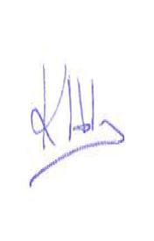

**Kate Holmes** – Interim CFO, Buckinghamshire CCG & Chair Bucks Vaccine Cell

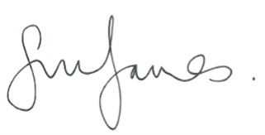

**Simon James** – Service Director: Education, Buckinghamshire Council

***Bucks Vaccination Team – 12-15 year old cohort***:

**Sam Smissen** – Buckinghamshire Immunisation Team Lead, Buckinghamshire Healthcare NHS Trust

**Jo Crawley** – Senior Clinical Lead Mass Vaccination Centres – Oxford Health NHS Foundation Trust

**Gareth Drawmer** – Head of Service, Achievement & Learning, Children’s Services, Buckinghamshire Council

**Kate Holmes** – Interim CFO, NHS Buckinghamshire CCG & Chair Bucks Vaccine Cell

**Tunde Adewopo** - Divisional Director/SRO Covid-19 Vaccinations, Specialist Services Buckinghamshire Healthcare Trust