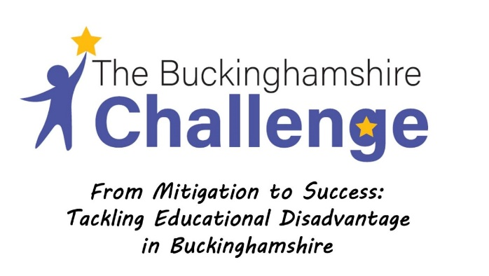
Newsletter 2 - Spring 2022

Addressing disadvantage: Spring update!

It’s been a long term! It has been a worrying term too, with the devastating conflict in eastern Europe and repercussions around the world.

Despite this, our programme has been thriving, notwithstanding the challenges of Covid 19 – both in keeping pupils in school and its impacts on pupils’ learning. THANK YOU very much. The commitment to the programme – attendance at online sessions and teachers, pupils and leaders opening their doors for strategy reviews has been brilliant. The liaison group work is going to be excellent.

One of the schools that has received a visit has been Ash Hill Primary School. They have produced and published an excellent Pupil Premium strategy document which can be accessed here. More about our learning from the visits in the next newsletter.

In our last workshops, there was some super input from a range of guest speakers. You can access the videos here (they are between 15 and 30 minutes):

- Lisa Tweed (Houldsworth Valley Primary Academy) – A whole school approach to disadvantage, focussing on school culture, instructional coaching, developing good language and communication and reading:
https://www.youtube.com/watch?v=lHz1mEiOgsg&list=PLvRF8jVGe0qRCSkV4CJvsI5fmx39KW5Dm&index=4

- Paul Kinder (Warlingham School) – Narrowing the focus – from trying to do everything to helping all pupils to thrive in the classroom. A focus on language and literacy
https://www.youtube.com/watch?v=5g6PeRsUHmk&list=PLvRF8jVGe0qRCSkV4CJvsI5fmx39KW5Dm&index=1

- Sarah Jones (Aspire AP) – Supporting vulnerable learners – including an excellent section on using Boxall profiles for identifying additional needs: https://www.youtube.com/watch?v=hNsb6Cgd7Gg&list=PLvRF8jVGe0qRCSkV4CJvsI5fmx39KW5Dm&index=2

- Neil Strain (Stoney Dean School) – Addressing disadvantage within a special school context: https://www.youtube.com/watch?v=r1pkYeX8p5k&list=PLvRF8jVGe0qRCSkV4CJvsI5fmx39KW5Dm&index=3

Some other videos that you might find helpful:

Marc Rowland (apologies for writing about myself!) on addressing disadvantage. You have heard a lot of this before but might be useful for colleagues
https://vimeo.com/671430554

Fran Haynes from Durrington Research School on the EEF’s CPD guidance.
https://vimeo.com/643409456/4d79282877

Stephen Parsons and Anna Branagan from ‘Word Aware’ on developing pupils’ language for behaviour and emotions.
https://www.youtube.com/watch?v=xOXVC3XFhS0

And some more resources around attendance (a big issue for us all!):
https://youtu.be/xOXVC3XFhS0?t=45

- Research evidence suggests that extrinsic rewards to improve attendance have little impact, and may have the opposite of the desired effect:

https://attendanceworks.org/wp-content/uploads/2017/09/Teaching-Attendance2.0-Summary_final.pdf

https://www.edutopia.org/article/extrinsic-motivation-it-might-be-even-worse-you-thought

- Margaret Mulholland on what evidence tells us about improving attendance:

https://www.tes.com/magazine/teaching-learning/general/what-research-tells-us-about-fixing-attendance

- Understanding the factor-categories that drive of poor attendance is key (physical health, mental health, systemic / attitudinal and school behaviour related)

https://www.bps.org.uk/sites/www.bps.org.uk/files/Policy/Policy%20-%20Files/Behaviour%20Change%20-%20School%20attendance%2C%20exclusion%20and%20persistent%20absence%20%282017%29.pdf

- Giving parents accurate information about how their child is attending compared to their peers can impact on behaviours. Creating a shared agency for attendance, in parent-friendly language is important.

https://leadinglearner.me/2017/07/02/absences-matter-and-you-can-help/

I hope these links are all useful to you.

The ongoing programme detail can be found below - a BIG thanks to the Buckinghamshire Challenge Team at the Local Authority for making this happen.

Save the date!

Thank you again for participating – and as we said last time, for all that you are doing for pupils and families.

Happy Easter!

Marc Rowland,
Buckinghamshire Challenge

