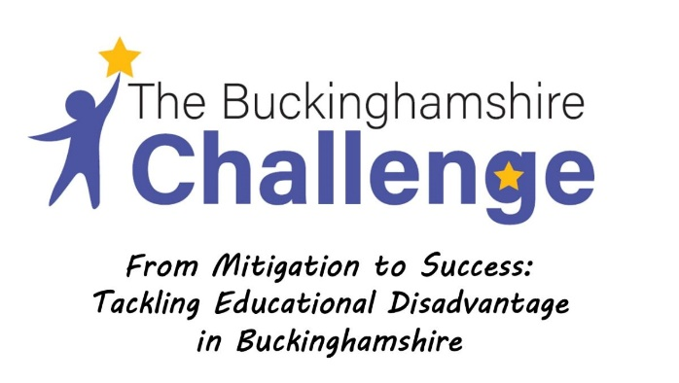
Newsletter 4 - Autumn 2022
Addressing disadvantage: Autumn update!

It’s getting closer to the Christmas break!

Again, we’d like to thank everyone for your commitment to addressing the impact of disadvantage in our education system. This is a long-term issue. But the cold wind of disadvantage has been particularly bitter during the cost of living challenges we are currently experiencing, alongside the long-term effects of Covid 19. We recognise the challenges in schools. The Buckinghamshire Challenge is here to support and supplement your work.

Here are some resources and guidance that should support your ongoing efforts:

Strategy
Addressing educational disadvantage – from strategy to the classroom (Unity Research School)
https://researchschool.org.uk/unity/news/addressing-educational-disadvantage-from-strategy-to-the-classroom

Reviewing and refining your Pupil Premium Strategy: seven steps and helpful evidence-informed resource (Unity Research School)
https://researchschool.org.uk/unity/news/reviewing-and-refining-your-pupil-premium-strategy-seven-steps-and-helpful-evidence-informed-resources

Language
Why reading aloud matters (Unity Research School)
https://researchschool.org.uk/unity/news/10-reasons-why-reading-aloud-matters

Reading
Using diagnostic assessments to guide reading interventions (Shotton Hall Research School)
https://researchschool.org.uk/shottonhall/news/how-we-use-diagnostic-assessments-to-guide-reading-interventions

Reflecting realities: diversity in children’s literature (Centre for Literacy in Primary Education)
https://clpe.org.uk/research/reflecting-realities

Reading ages: what does the research say (Dr Jessie Ricketts – TES)
https://www.tes.com/magazine/teaching-learning/general/reading-ages-what-does-research-say

Attendance
Evidence review of attendance strategies (Education Endowment Foundation)
https://educationendowmentfoundation.org.uk/education-evidence/evidence-reviews/attendance-interventions-rapid-evidence-assessment

Numeracy
Using storybooks to promote high quality talk in Maths (Education Endowment Foundation)
https://educationendowmentfoundation.org.uk/news/using-storybooks-to-promote-high-quality-talk-in-maths

Tuition
Making the difference with tutoring (Education Endowment Foundation)
https://d2tic4wvo1iusb.cloudfront.net/uploads/Tutoring_Guide_2022_V1.2.pdf

Governance
Widening the lens on disadvantage (National Governance Association)
https://www.nga.org.uk/getmedia/f29b1fc2-131d-4320-95c4-9885519aa7cd/nga-widening-lens-disadvantage-20221124.pdf

January 2023
We look forward to seeing many of you on 16th January with a review of the project in the morning and the champion schools focussing on priorities in your liaison groups in the afternoon. Details of the liaison group programme can be seen in the infographic below. We will be setting out our emerging thinking around a strategic approach to addressing disadvantage in Buckinghamshire at the event too. So your views on this are really important.

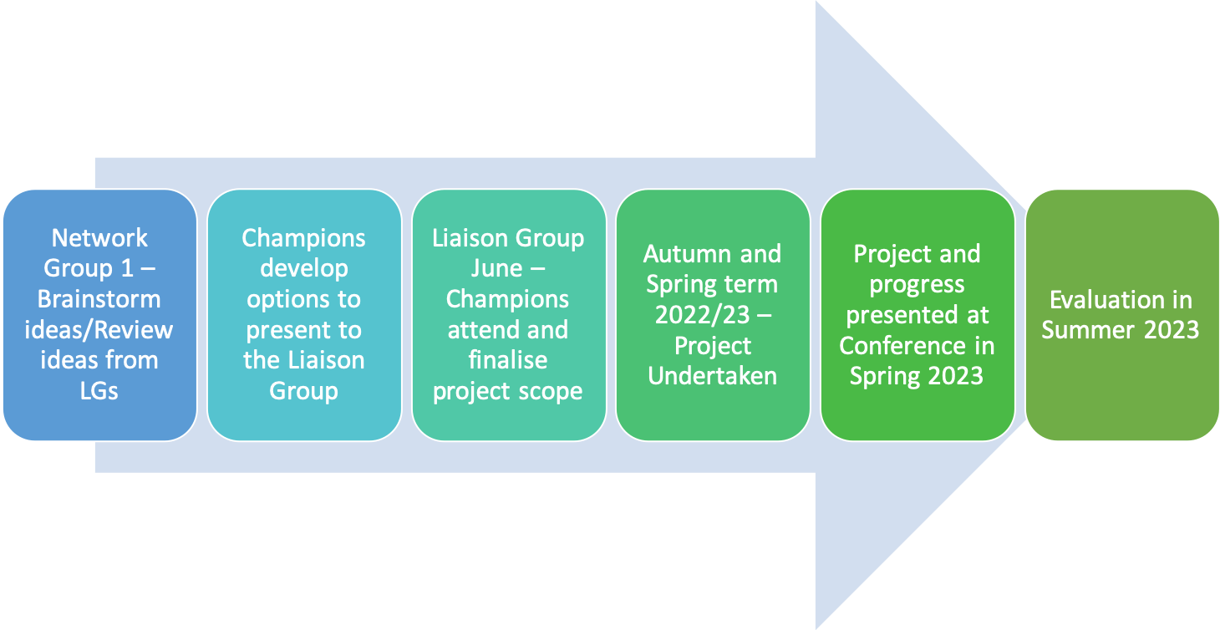

We are hugely grateful to our liaison group champion schools – and everyone who has positively engaged - for helping develop a school led disadvantage strategy. Our champions are as follows:

Liaison Group | Disadvantaged Champion School
Rye | Ash Hill
Aylesbury Town 1 | Bedgrove Infant School
Aylesbury Town 2 | Turnfurlong Junior
Chalfonts | Chalfont St Giles Village School
Amersham | Chesham Bois
Wing | The Cottesloe School
Cressex | The Disraeli School
Bernwode | Haddenham Juniors
Evreham | Iver Village Infant
Wye Valley | Juniper Hill
Princes Risborough | Monks Risborough
John Colet | Sir Henry Floyd Grammar
Burnham | St Nicolas', Taplow
Buckinghamshire & Winslow | Steeple Claydon
Chesham | Waterside Primary Academy

Themes – agreed locally – include:

- Vocabulary
- Oracy
- Metacognition
- Parental involvement
- Rosenshine’s principles
- Social and emotional learning
- Ukrainian students
- Writing
- Enrichment

Details of the event can be found below. We are really looking forward to seeing you there:

- Monday 16th January 2022
- The Gateway, Gatehouse Road, Aylesbury, HP19 8FF
- 9.30 – 12.15 All schools engaged in Universal Offer
- 1.30 – 3.00 Champion Schools only
- Parking is free
- Refreshments will be provided

Thank you again for participating. Happy Christmas!

Marc Rowland, Buckinghamshire Challenge

